FloodSight
Flood Monitoring Website Dashboard
Development Progress Report

Prepared: August 8, 2026
Branch: mongoDB-atlas-connection

1. Project Overview
FloodSight is a web-based flood monitoring dashboard built for Cagayan de Oro City. It gives authorized users a real-time view of flood conditions at multiple CCTV-monitored locations by combining a live camera feed experience, a map overview of flood-prone areas, and role-based administrative controls for camera configuration and user access.
The project began as a frontend prototype driven by seeded demo data and has since progressed toward a real backend: it now connects to a MongoDB Atlas database for camera/flood records and includes a live CCTV snapshot proxy for pulling images directly from IP cameras. This report documents that progression from the first scaffolded commit to the current state of the codebase.
1.1 Primary Users
- Viewer — can log in and view the dashboard.
- Authority — can view monitoring data and act on alerts.
- Admin — can configure cameras, manage users, and control access-related settings.
1.2 Core Goals
- View the current flood status of multiple monitored locations at a glance.
- Quickly identify areas that are Normal, Alert, or Danger.
- Inspect camera snapshots with associated water level and timestamp data.
- Access the system through authenticated Google sign-in.
- Manage camera configuration and user roles when authorized as an admin.
2. Technical Stack & Architecture
The application is built on the following stack:
- React 19 with TypeScript
- Vite as the build tool, TanStack Start for SSR
- TanStack Router for file-based application routing
- TanStack Query for async state handling
- Tailwind CSS v4 and shadcn-style UI primitives (Radix UI)
- Firebase Authentication for Google sign-in and identity
- MongoDB Atlas for camera/flood-status persistence
- Leaflet for interactive map rendering
- Lucide React for icons
2.1 Application Structure
Source code is organized by responsibility under src/:
src/routes/ — TanStack Router file-based route modules (pages).
src/components/floodsight/ — Dashboard-specific components — AppShell, CameraMap, StatusBadge.
src/components/auth/ — Authentication UI — Login page and PrivateRoute guard.
src/components/ui/ — 41 shared Radix/shadcn-style UI primitives (buttons, dialogs, tables, etc.).
src/lib/floodsight/ — Domain types (types.ts) and the client-side state store (store.ts).
src/lib/*.server.ts — Server-only modules: MongoDB access and the live camera-stream proxy.
src/context/ — React context providers, chiefly AuthContext for Firebase auth state.
src/services/ — External service clients (Firebase).
src/server.ts — Custom server entry exposing the REST API before falling through to SSR.
2.2 Data Model
Camera object:
- id, location, coordinates ({lat, lng})
- waterLevel (meters), floodStatus (NORMAL | ALERT | DANGER)
- timestamp, snapshotUrl
- streamConfig (ipAddress, port, username, password, snapshotPath) — for live CCTV connection
- roiConfig ({x, y, width, height}) — Region of Interest for water-level detection
- hsvThresholds ({h_min, h_max, s_min, s_max, v_min, v_max}) — OpenCV color thresholds
User object:
- id, name, email, role (admin | authority | viewer)
- avatarUrl / photoURL, addedAt
Flood status is derived from water level: ≥ 1.5 m is DANGER, ≥ 0.5 m is ALERT, otherwise NORMAL (implemented in statusFromLevel(), src/lib/floodsight/types.ts).

3. Development Timeline
The project's git history shows five clear phases of work, moving from an AI-scaffolded template to a functioning prototype, then to a real MongoDB-backed and live-camera-integrated dashboard.
Phase 0 — Project Template
The repository started from a TanStack Start + Vite template (commit da9a015), providing the base tooling: Vite, Tailwind v4, shadcn/ui primitives, ESLint, and Prettier, with no application-specific code yet.
Phase 1 — Initial Dashboard Build (June 15, 2026)
In a single rapid AI-assisted scaffolding session (16 commits within a five-minute span, ending in “Added auth and dashboard routes”), the first working version of the dashboard was built under the original project name “Subay.” This session produced:
- The authenticated route layout (_auth.tsx) and its child routes: dashboard (_auth.index.tsx), camera configuration (_auth.config.tsx), and user access management (_auth.users.tsx).
- The login route and initial AppShell navigation chrome.
- The core UI components: AppShell, CameraMap (Leaflet-based), and StatusBadge.
- The client-side data layer: src/lib/subay/types.ts (data model) and store.ts (useSyncExternalStore-based state, seeded with demo camera/user records).
16 files changed, ~1,360 lines added in this session — effectively the entire application skeleton.
Phase 2 — Authentication & Profile Polish (June 22, 2026)
Commit 26a8456 (“Refine Google Auth Login Page, Profile Picture is clickable and leads to profile page, and change login page old background color and text”) added real Firebase Google authentication:
- src/context/AuthContext.jsx introduced as the app-wide auth provider.
- src/components/auth/Login.jsx and PrivateRoute.jsx added for the sign-in screen and route guarding.
- src/pages/ProfilePage.jsx and the /profile route added, with the header avatar made clickable.
- src/services/firebase.js (and an early firebase.ts variant) added to initialize Firebase Auth.
Phase 3 — MongoDB Atlas Integration (July 18–20, 2026)
Commit 3b533bd (“feat: add MongoDB Atlas camera integration”), together with the engineering notes in LOGS.md, connected the dashboard to a real database for the first time:
- src/lib/db.server.ts added: a MongoDB client with connection reuse across hot reloads, camera document normalization, and automatic collection detection.
- GET /api/cameras added in src/server.ts to serve normalized camera feeds from MongoDB.
- The dashboard (_auth.index.tsx) reworked to poll /api/cameras and merge live DB data into the camera carousel, tracking a connection status (connecting / connected / error).
- A dev-only localStorage authentication fallback added to AuthContext.jsx so the dashboard could be tested locally without a live Google OAuth session.
- Admin access reworked from a manual toggle to an email-based rule (ADMIN_EMAIL), and the User Access page (_auth.users.tsx) reworked to manage real, persisted user roles.
Notable issues encountered and resolved during this phase (from LOGS.md): an initial .env pointing at the wrong database/collection; an infinite “Redirecting to sign in…” loop on the login route, fixed with a location check in _auth.tsx; and a Firebase popup sign-in failure specific to the VS Code built-in browser (COOP/origin-isolation issue), resolved by using an external browser for interactive sign-in.
Phase 4 — Live Camera Streaming (July 29, 2026)
Commit f527068 (“Fix SSR camera stream import and add server-side camera snapshot proxy with StreamConfig support”) added the ability to pull live snapshots directly from IP cameras:
- src/lib/camera-stream.server.ts added: fetches a live snapshot from a camera's IP, handling HTTP Digest and Basic auth challenges and validating the response is an image, with an 8-second timeout.
- Two new endpoints in src/server.ts: POST /api/cameras/:id/snapshot/test (preview a candidate IP before saving) and GET /api/cameras/:id/snapshot (proxy a persisted camera's live snapshot).
- StreamConfig support added to the Camera type and MongoDB persistence layer.
- The Camera Configuration page (_auth.config.tsx) extended with connection settings (IP, port, credentials, snapshot path) and a live snapshot preview.
- A server-side module resolution bug fixed by importing camera-stream.server.ts explicitly, so the SSR bundler could resolve the implicit .server module path.
Phase 5 — Rebrand to FloodSight (Current, Uncommitted)
The most recent working-tree changes rename the project from its original codename “Subay” to “FloodSight”: src/components/subay/ and src/lib/subay/ were replaced 1:1 by src/components/floodsight/ and src/lib/floodsight/, with all routes updated to import from the new paths. This phase also includes minor route, login, and profile page adjustments and continued work on the MongoDB Atlas connection on the mongoDB-atlas-connection branch.

4. Feature Walkthrough
The following pages were captured directly from the running local development build to illustrate the current state of the dashboard. Screenshots use the built-in demo/dev data (seeded camera records with placeholder imagery), since the project remains a prototype with live-camera and database integration layered on top of that seeded state.
4.1 Login
Users sign in with their Google account through Firebase Authentication. The login screen (src/components/auth/Login.jsx) presents FloodSight branding and a single “Sign in with Google” action, with friendly error handling for common Firebase auth failures (unauthorized domain, popup blocked, etc.). Unauthenticated visitors to any protected route are redirected here by the authenticated layout guard (src/routes/_auth.tsx).
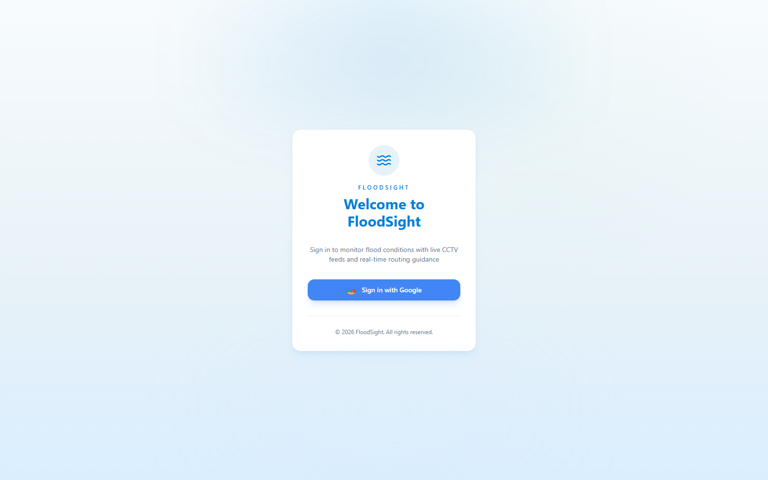
Figure 1 — Login screen
4.2 Dashboard
The main dashboard (route: /, src/routes/_auth.index.tsx) is the “Live Flood Watch” overview. It shows summary counts of cameras by status (Normal / Alert / Danger), a horizontally scrollable camera feed carousel, a focused detail panel for the selected camera (snapshot with ROI overlay, water level, coordinates, last-updated time), and a Leaflet-based map of Cagayan de Oro with color-coded markers per monitored location. Data merges seeded demo cameras with live records fetched from MongoDB via GET /api/cameras, refreshing automatically on a timed interval.
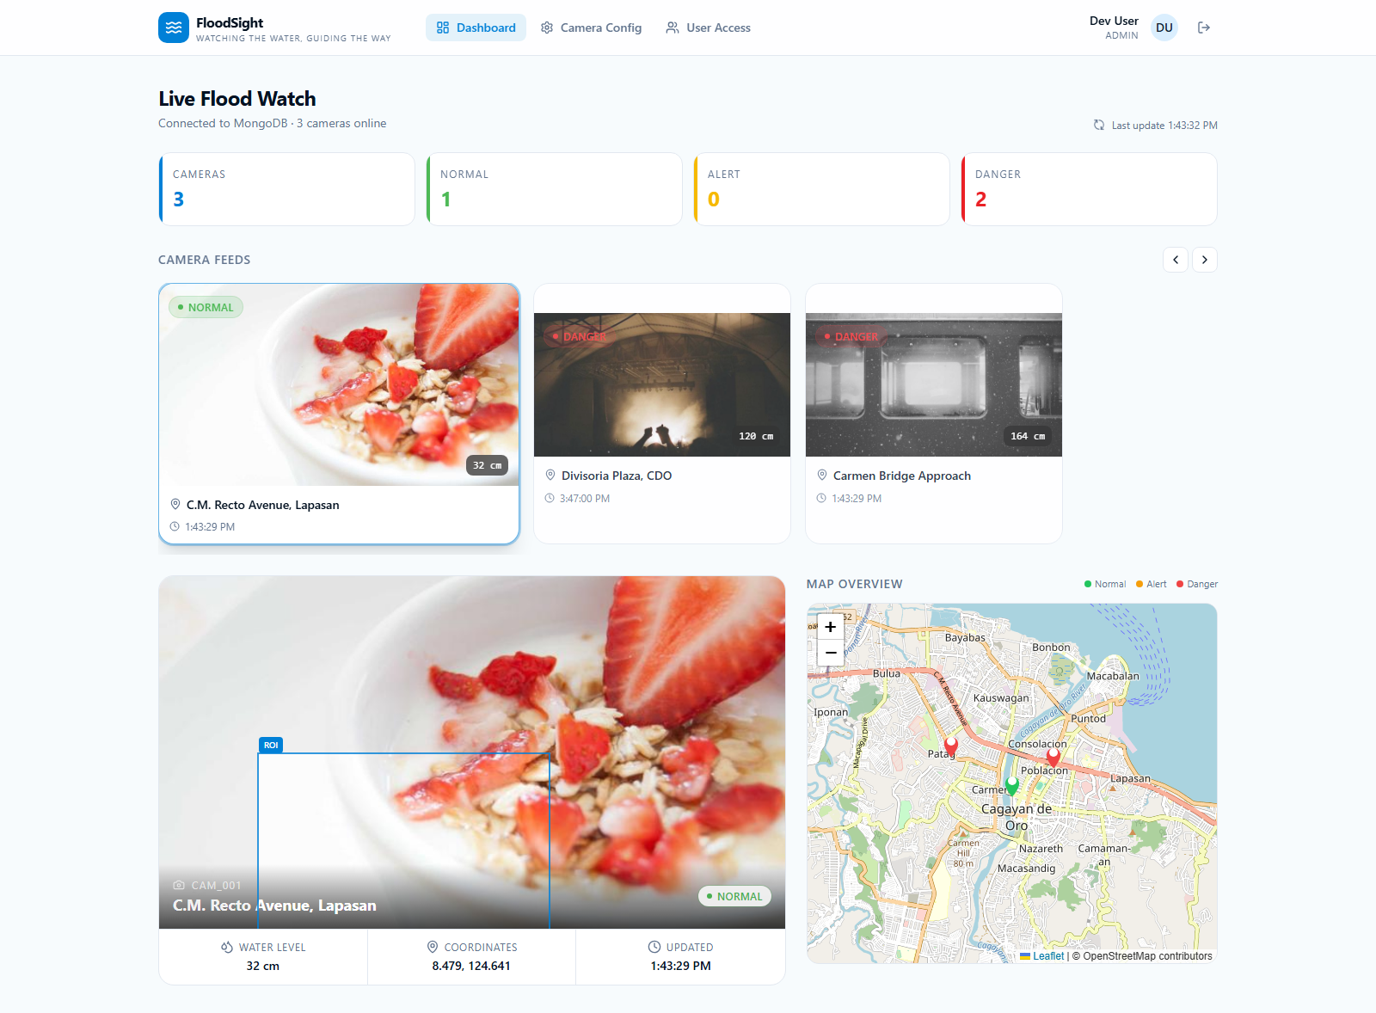
Figure 2 — Dashboard / Live Flood Watch
4.3 Camera Configuration (Admin)
Restricted to admin users, this page (route: /config, src/routes/_auth.config.tsx) lets an administrator tune each camera's detection settings: location name, latitude/longitude, camera connection details (IP address, port, credentials, snapshot path) with a live snapshot preview, a draggable Region of Interest (ROI) overlay on the snapshot, and OpenCV HSV color threshold presets (Green / Orange / Red) used for water-marker detection. Saved changes persist to MongoDB via PATCH /api/cameras/:id.
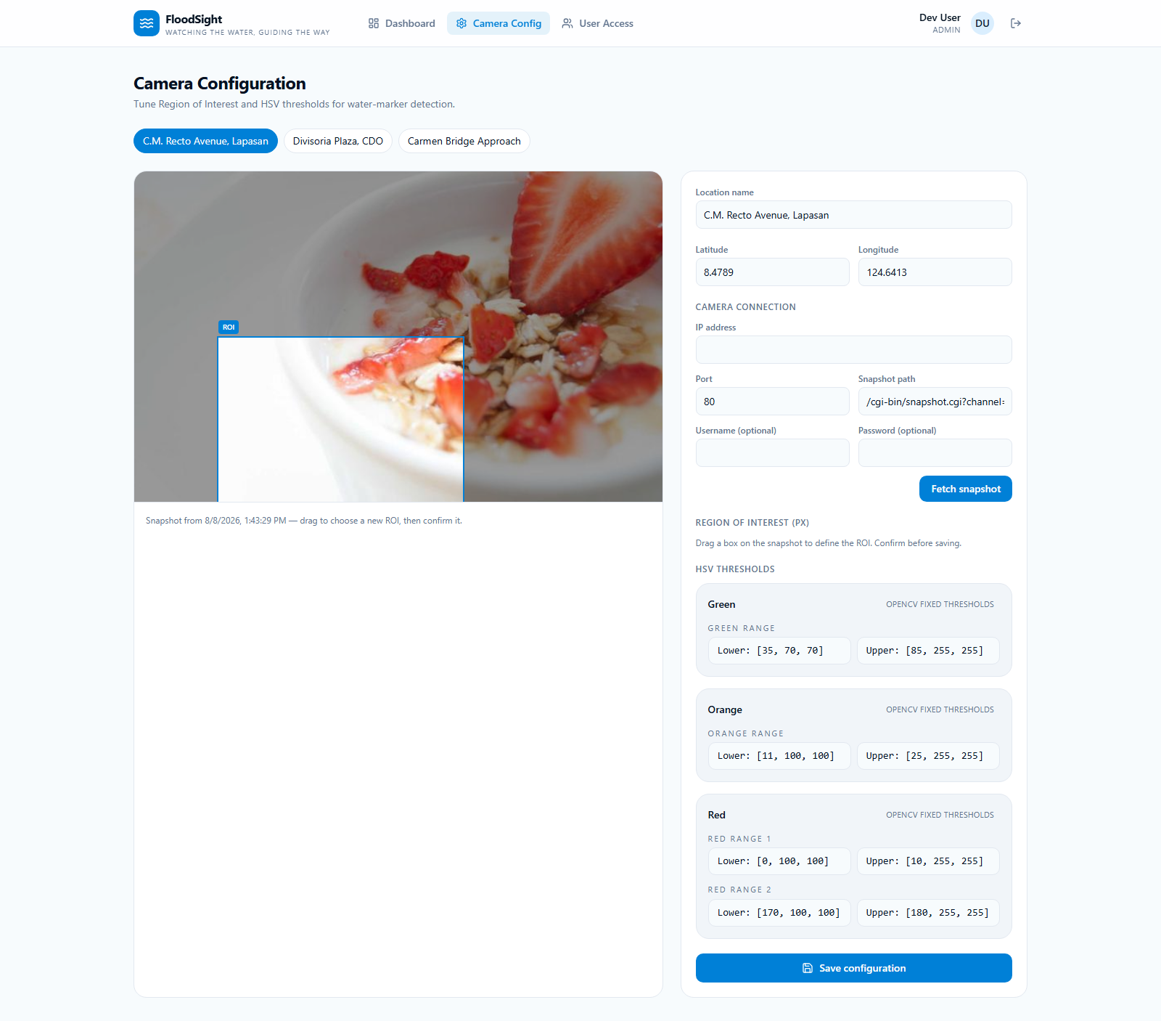
Figure 3 — Camera Configuration page
4.4 User Access (Admin)
Also admin-only, this page (route: /users, src/routes/_auth.users.tsx) manages the roster of accounts and their roles (admin, authority, viewer). Admins can add a user by name/email/role, change an existing user's role inline, and remove users — with the current signed-in admin prevented from removing their own account. The roster is backed by the persisted user store and synced with real Google-authenticated accounts as they sign in.
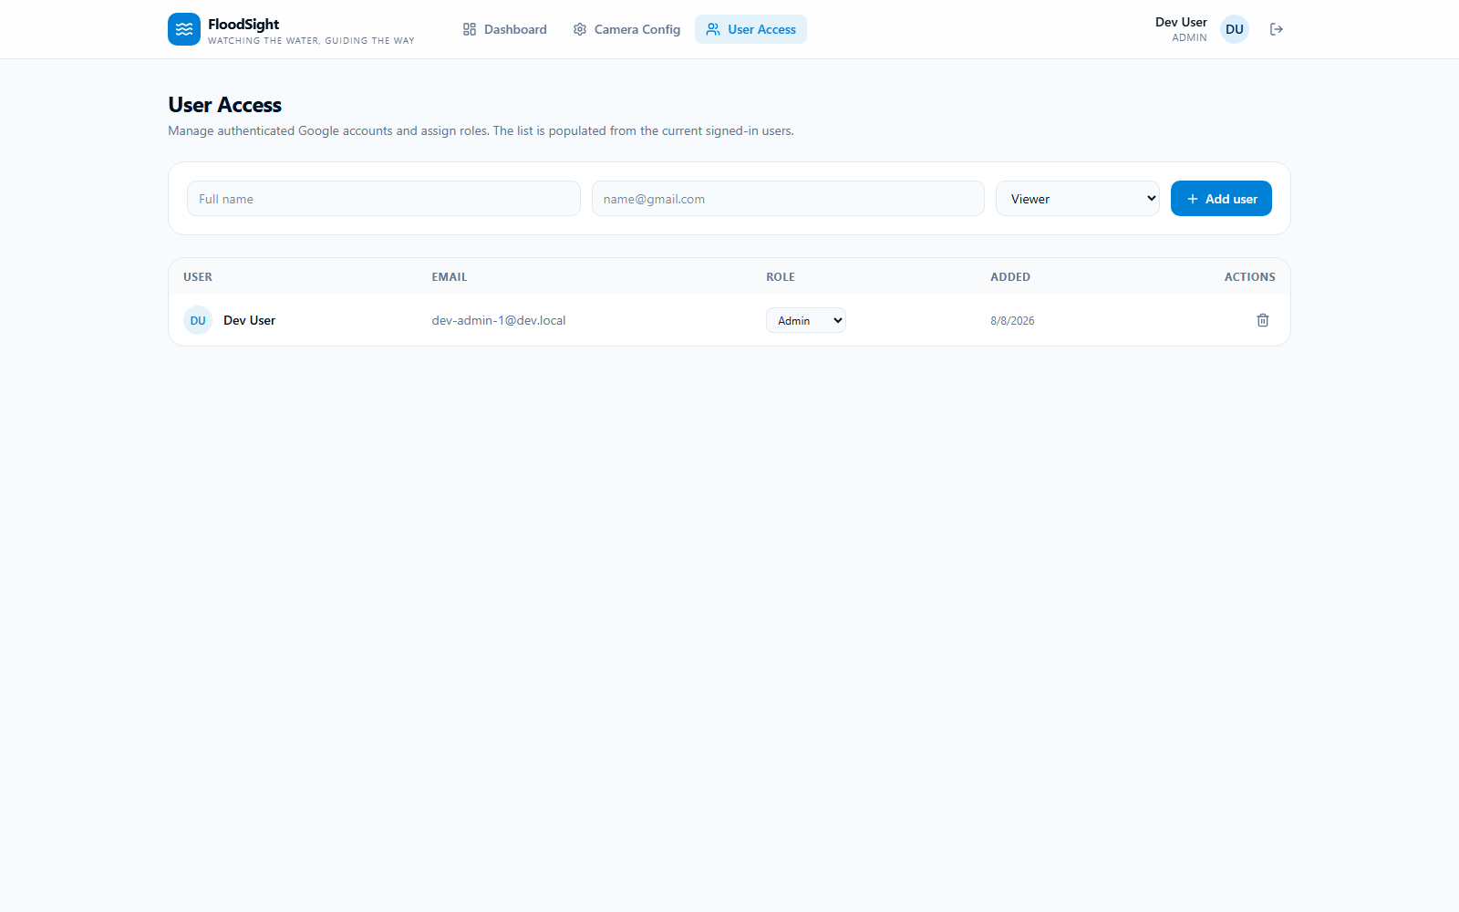
Figure 4 — User Access management
4.5 Profile
The profile page (route: /profile, src/pages/ProfilePage.jsx) shows the signed-in user's avatar (falling back to their Google profile photo when available), name, email, and current role, along with quick actions to return to the dashboard or sign out.
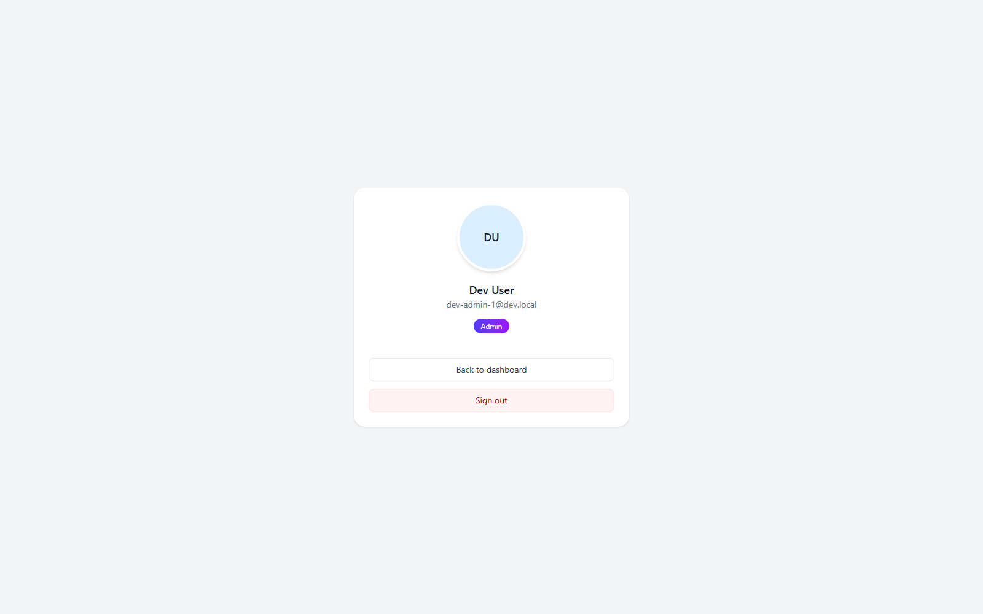
Figure 5 — Profile page

5. Backend & Data Layer
5.1 MongoDB Atlas Integration
src/lib/db.server.ts manages a cached MongoDB client (surviving hot-module reloads in development) and exposes:
- getCameraFeeds() — reads camera documents, auto-detecting the right collection by looking for water_level / status / GeoJSON location fields if the configured collection is empty, and normalizes raw Mongo documents into the app's Camera type.
- updateCameraFeed(id, camera) — upserts a camera document (location as GeoJSON Point, water level, status, timestamp, ROI config, HSV thresholds, and optional stream config).
Configuration is read from environment variables: MONGODB_URI, MONGODB_DB, MONGODB_COLLECTION.
5.2 REST API (src/server.ts)
GET /api/cameras — list all camera feeds from MongoDB
PATCH /api/cameras/:id — upsert a camera's configuration
GET /api/cameras/:id/snapshot — proxy a camera's live snapshot image
POST /api/cameras/:id/snapshot/test — test-fetch a snapshot for a candidate IP config

The server also wraps SSR responses to normalize framework-level 500 errors into a friendly error page and logs captured errors for diagnosis.
5.3 Live Camera Streaming
src/lib/camera-stream.server.ts fetches snapshot images directly from CCTV IP cameras. It builds the snapshot URL from a camera's StreamConfig, implements HTTP Digest authentication by hand (via Node's crypto module) as well as Basic auth, enforces an 8-second timeout via AbortController, and validates that the response is actually an image before returning it. Typed errors (CameraUnreachableError, CameraAuthError, CameraTimeoutError, CameraResponseError) let the API layer map failures to the correct HTTP status codes.
5.4 Authentication
src/context/AuthContext.jsx wraps the app in a React context that listens to Firebase's onAuthStateChanged, resolves each user's role (admin is granted automatically to a configured admin email; otherwise the role is read from the persisted user store, defaulting to viewer), and syncs authenticated users into the local user store. In local development, a fallback reads a seeded currentUserId from localStorage (key floodsight-state-v1) and synthesizes a fake signed-in user, letting the dashboard be exercised end-to-end without a live Google OAuth session.
5.5 Client-Side State
src/lib/floodsight/store.ts implements a dependency-free global store on top of React's useSyncExternalStore, persisted to localStorage under the key floodsight-state-v1. It holds the camera list, user roster, and current user, seeded with demo data for the prototype, and exposes action methods (addUser, updateUserRole, removeUser, updateCamera, syncCameras, upsertUserFromAuth, tickFloodData) so all state mutation goes through a single, predictable path rather than ad hoc component-level mutation.

6. Known Issues & Next Steps
6.1 Known Issues
- TanStack Start dev HMR occasionally logs “Invalid server function ID” warnings, left over from an earlier server-function code path that has since been bypassed by the direct /api/cameras handler; these are non-blocking but should be cleaned up separately.
- Google Sign-In via popup fails inside the VS Code built-in browser webview due to COOP/origin isolation (auth/popup-closed-by-user); sign-in works normally in external browsers such as Chrome or Firefox.
- Of the three seeded demo cameras, only one (Divisoria / cam_002 mapping) is confirmed wired to live MongoDB data by spatial-proximity matching; the remaining two feeds are still on seeded/demo values pending explicit camera-id based mapping.
- The MongoDB-to-camera mapping currently matches by nearest coordinates; a deterministic mapping by explicit camera ID is recommended once the DB schema is finalized.
6.2 Suggested Next Steps
- Wire the remaining camera feeds to their MongoDB records with explicit ID-based mapping.
- Clean up leftover TanStack Start server-function artifacts to silence the dev HMR warnings.
- Consider an automatic signInWithRedirect fallback (or a UI prompt to open externally) for environments where the Google Sign-In popup is blocked.
- Continue the Subay → FloodSight rebrand cleanup and commit the renamed component/lib directories on the mongoDB-atlas-connection branch.

